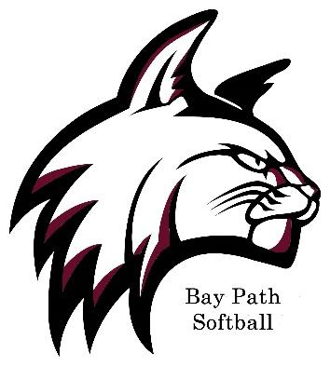
2020 Bay Path University
Softball Roster
No. | Name | Pos. | Cl. | B/T | Hometown/High School
# | Name | Pos. | Yr. | B/T | Hometown/High School
1 | Samantha Lisi | 3B/C | Jr. | R/R | Lincoln, R.I. /Davies Technical
5 | Rebekah Walker | OF | Jr. | R/R | Southbridge, Mass./Southbridge High School
11 | Kayla Vance | P/SS | Jr. | R/R | Clifton, NJ /Clifton High School
12 | Elizabeth Gross | P/SS | Fr. | R/R | Hyde Park, NY / Franklin D. Roosevelt
13 | Diane Almonte Arias | OF | Fr. | R/R | Hartford, Conn. /Civic Leadership
17 | Noelle Bisignano | OF | Jr. | R/R | West Greenwich, R.I. /Cranston High School East
19 | Lilly West | C | Sr. | R/R | Goshen, Mass. /Hampshire Regional
23 | Meghan Connors | UTL | So. | R/R | Pawtucket, R.I. /Davies Technical
24 | Faith Ruggiero | LF | Fr.. | R/R | East Windsor, Conn. /East Windsor
43 | Taylor Feraco | 1B | Sr. | L/L | Oxford, Mass. /Southbridge High School
44 | Kamryn McCorison | OF | So. | S/R | Southwick, Mass. /Southwick Regional

Head Coach: Steve Smith (17th season)
Asst. Coach: Andy Goodhart (4th season)
Head Athletic Trainer: Nicole Pease

